**MODULE -4**

# What are the main factors that can affect PPC bidding?

Once you’ve created your new campaigns, you’ll need to manage them regularly to make sure they continue to be effective. In fact, regular account activity is one of the best predictors of account success. You should be continuously analysing the performance of your account and making the following adjustments to optimize your campaigns;

* **Add PPC Keyword:** Expand the reach of your PPC campaigns by adding keyword that are relevant to your business.
* **Add Negative Keyword:** Add non-converting terms as negative keyword to improve campaign relevancy and reduce wasted spend.
* **Reviews Costly PPC Keyword:** Review expensive, under-performing keyword and shut them off if necessary.
* **Refine Landing Pages:** Modify the content and calls –to-actin (CTAs) of your landing pages to align with individual search queries in order to boost conversion rates. Don’t send all your traffic to the same page.

# How does a search engine calculate actual CPC?

The average amount that you’ve been charged for a click on your ad. Average cost-per-click (avg. CPC) is calculated by dividing the total cost of your clicks by the total number of clicks.

* Your average CPC is based on your actual cost-per-click (actual CPC), which is the actual amount you’re charged for a click on your ad. Note that your average CPC might be different from your maximum cost-per-click (max. CPC), which is the highest amount that you’re willing to pay for a click.
* Here’s an example of how to calculate your average CPC. Let’s say your ad gets two clicks, one costing $0.20 and one costing $0.40, for a total cost is $0.60. you’d divide $0.60 (your total cost) by 2 (your total number of clicks) to get an average CPC of $0.30.

# What is a quality score and why it is important for Ads?

A quality score is a metric used by Google Ads (formerly known as Google AdWords) to evaluate the relevance and quality of ads and keywords used in a pay-per-click (PPC) advertising campaign. The quality score is calculated based on factors such as the ad’s expected click-through rate, the relevance of the ad to the keyword and landing page, and the quality and relevance of the landing page itself.

Quality score is important for ads because it directly affects the cost and positioning of ads in Google’s search results. Ads with a high-quality score can achieve a higher ad rank and appear at the top of search results, while also paying a lower cost-per-click (CPC). Conversely, ads with a low-quality score may be ranked lower and require a higher CPC to achieve a competitive position.

Additionally, a high-quality score can help improve the overall performance of a PPC campaign by driving more clicks and conversions while keeping costs low. By creating relevant and high-quality ads and landing pages, advertisers can increase their quality score and improve the effectiveness and ROI of their advertising efforts.

# Create an ad for your website/blog in Google Ads that display on the display network with the properly targeted audience.

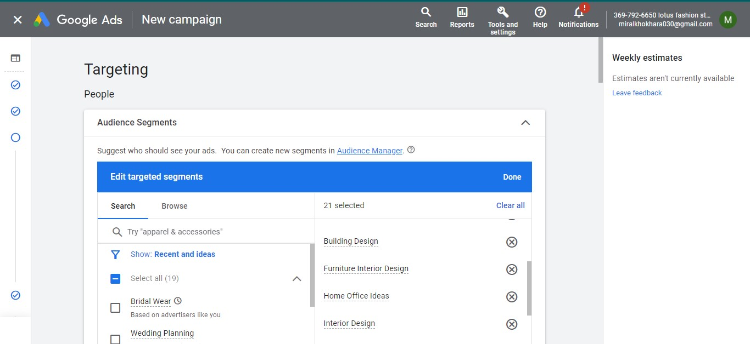

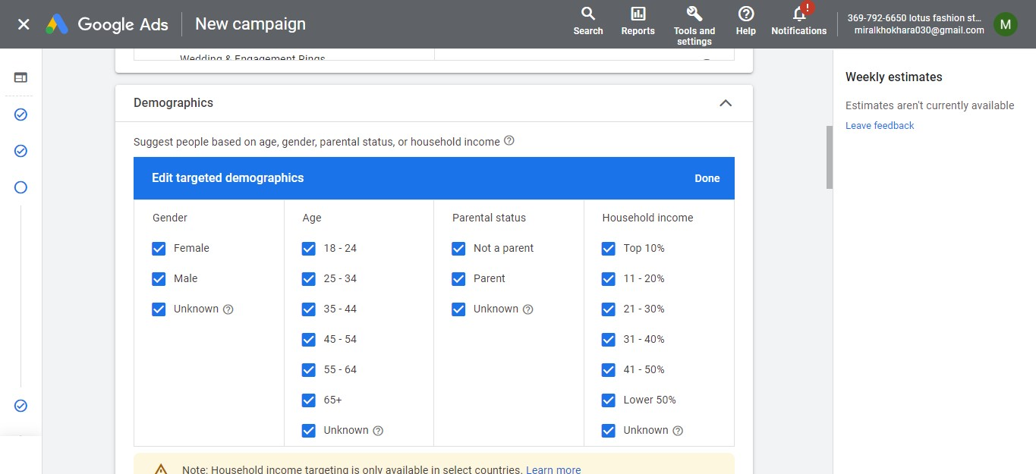

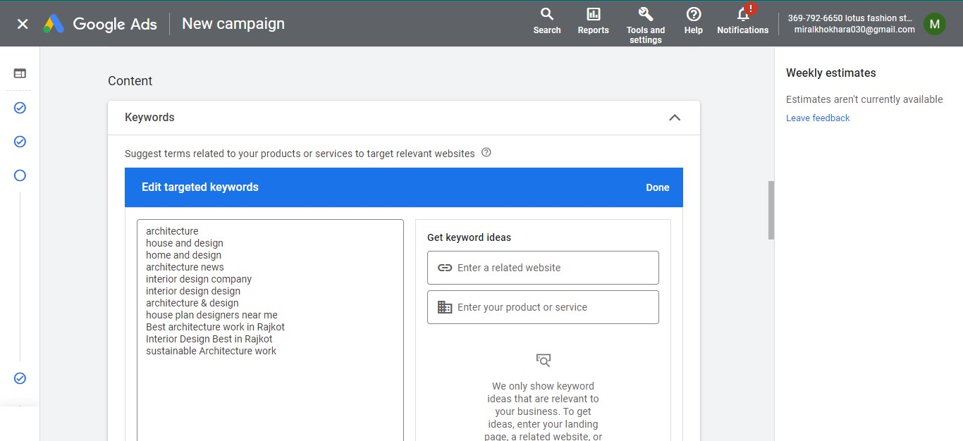

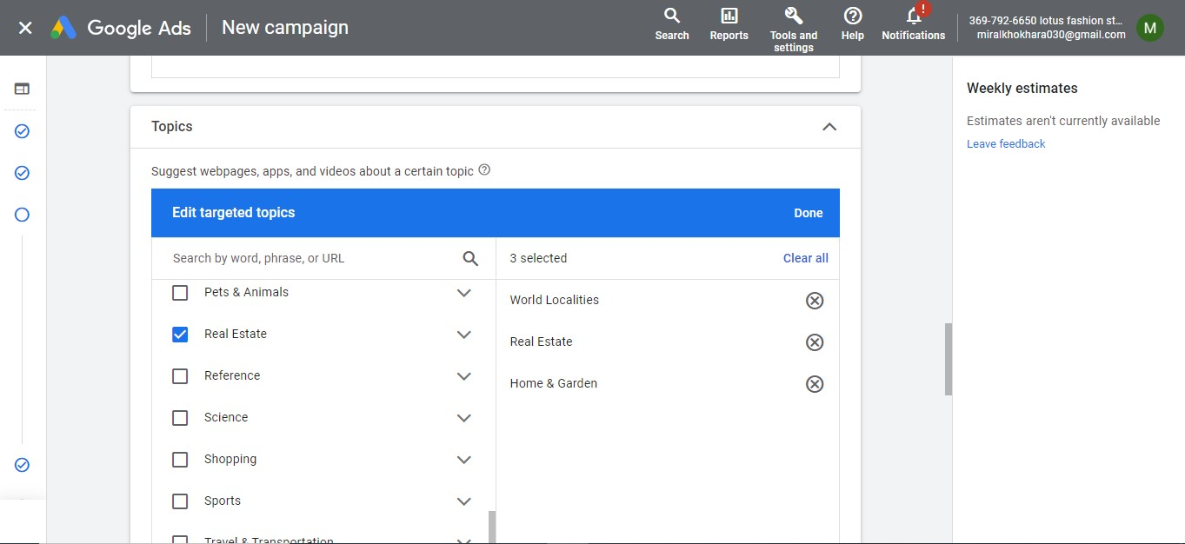

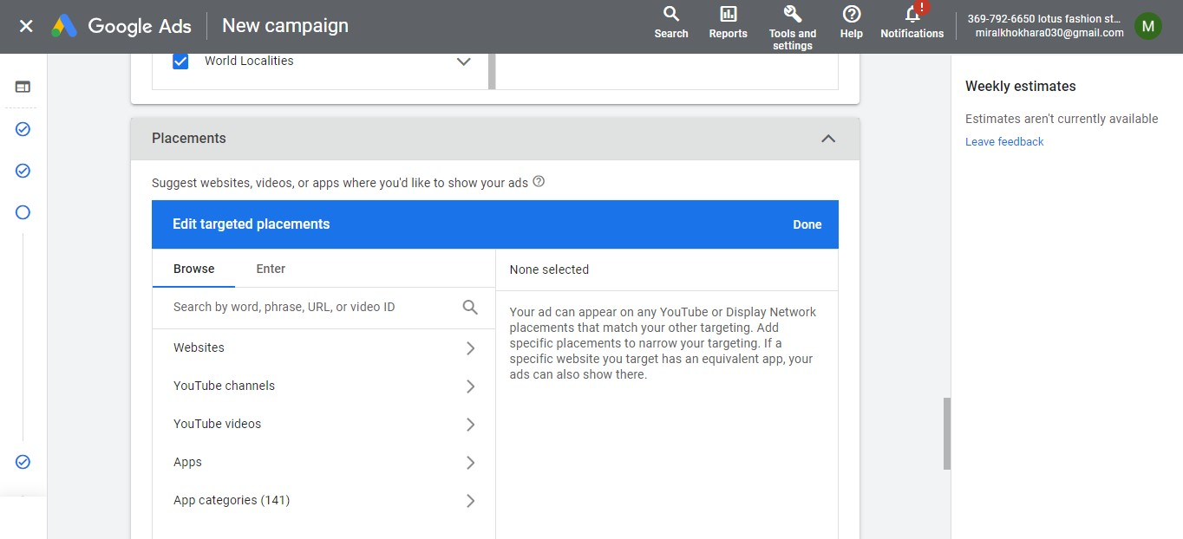

# Create an ad for <http://esellerhub.com/> to get the maximum clicks.

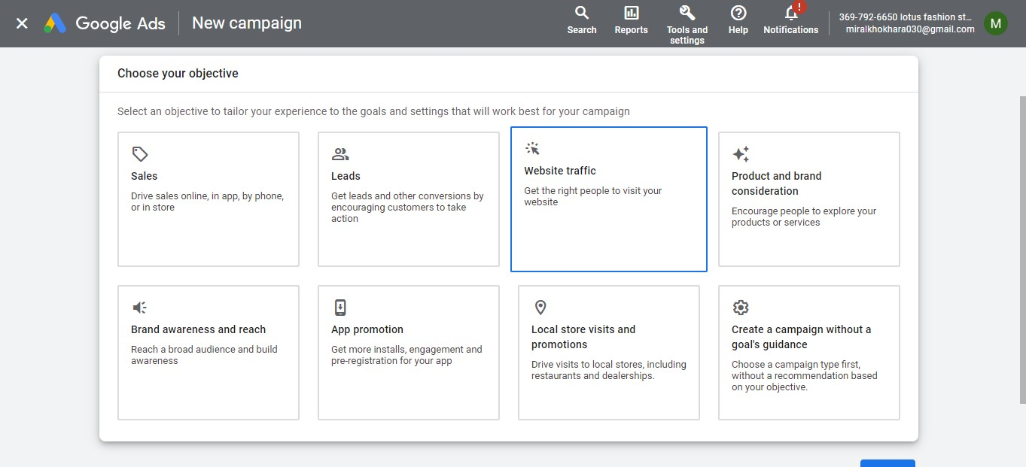

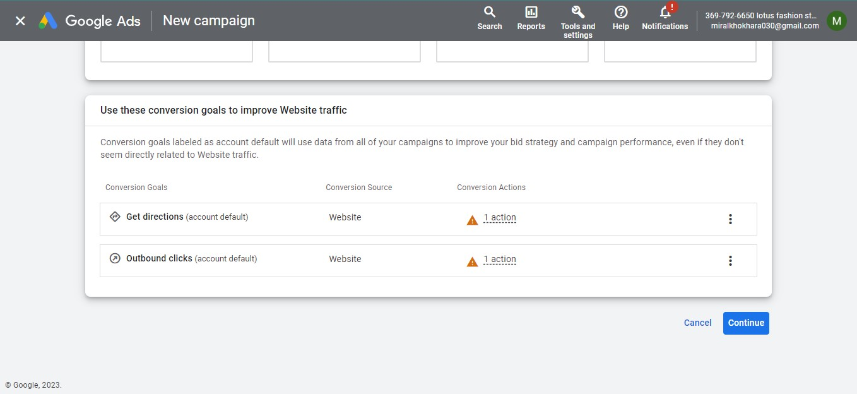

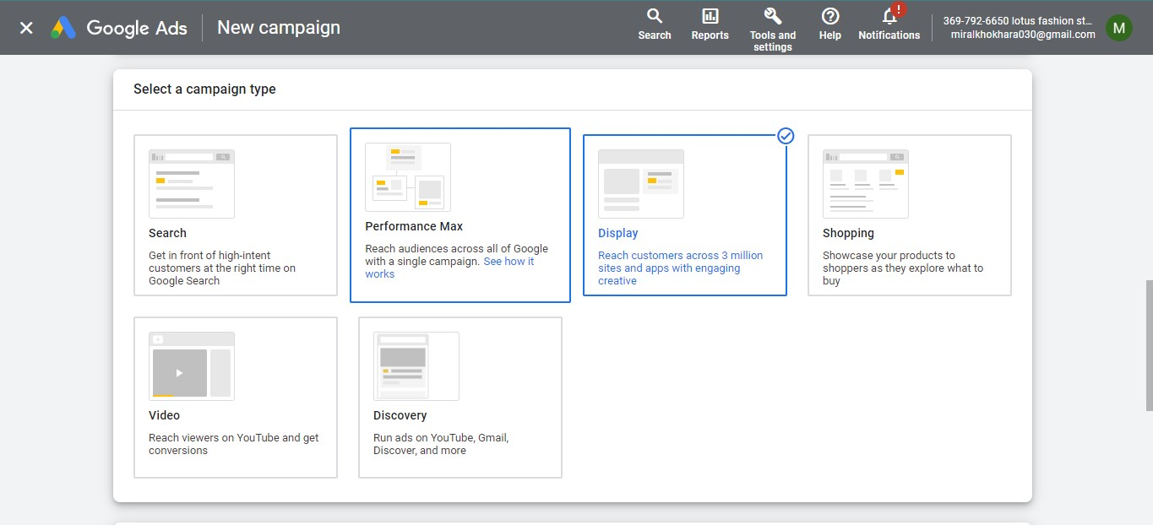

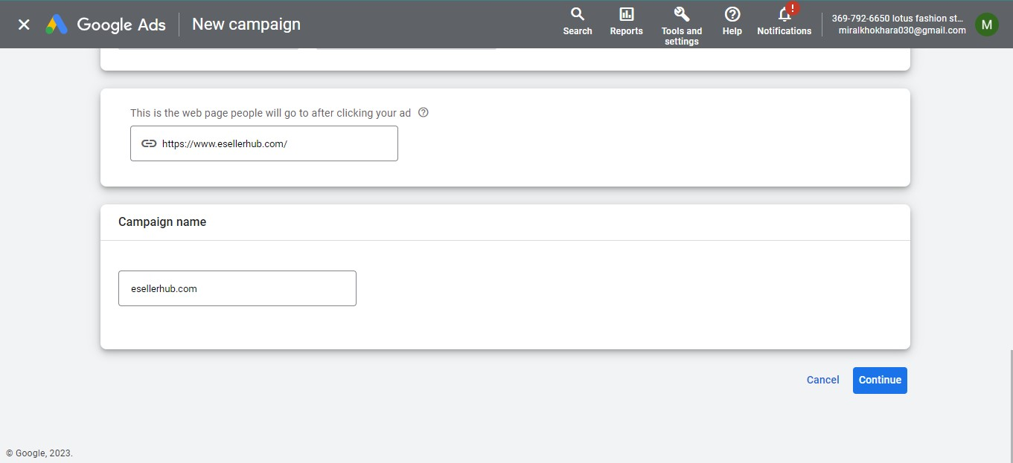

# Create an ad for <http://www.designer2developer.com>

* Create an ad for the display network
* Choose a proper Target audience.
* Expected conversion: need maximum user engagement within the budget.
* Budget: 5000.

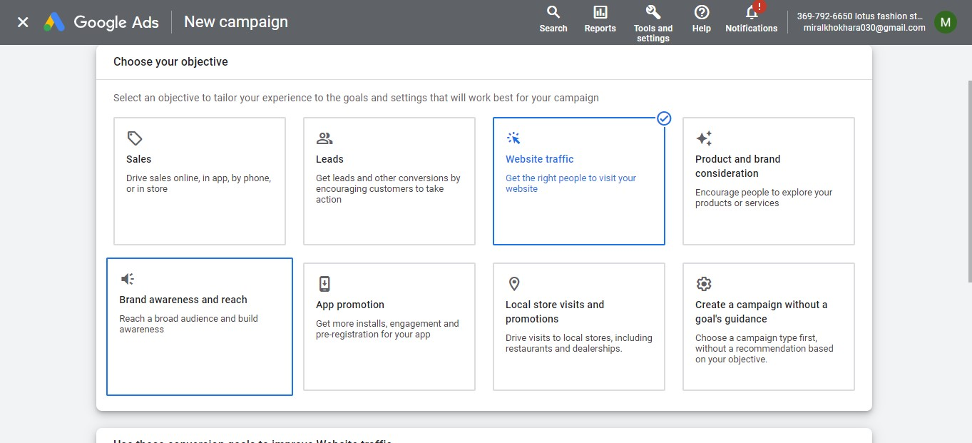

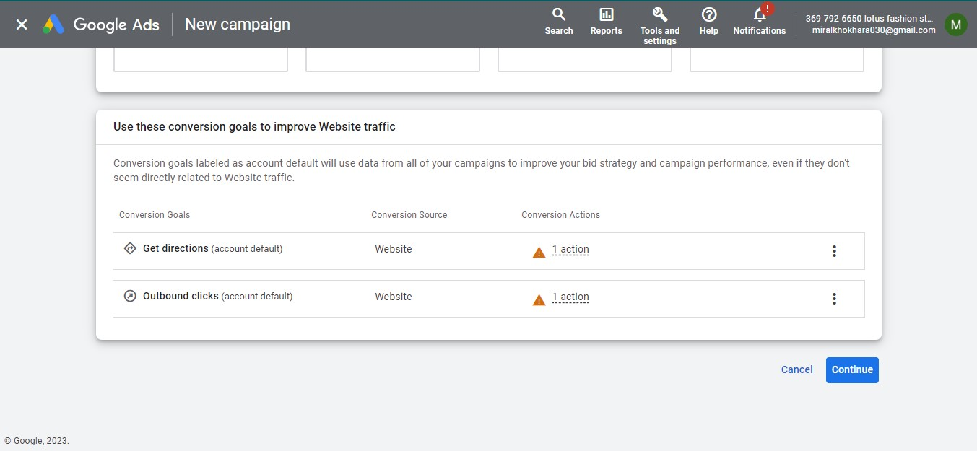

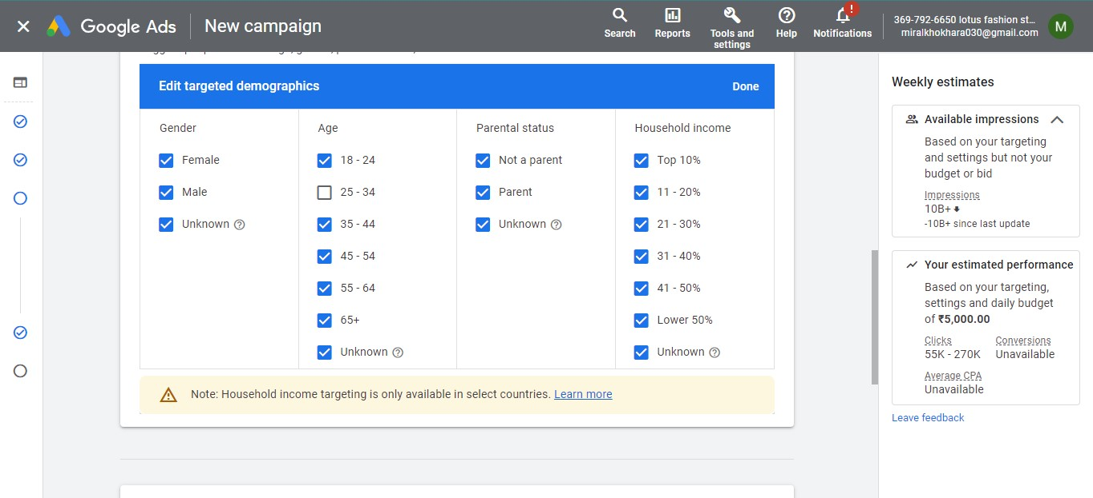

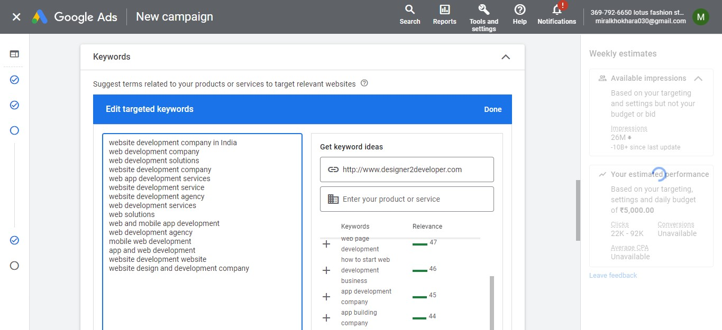

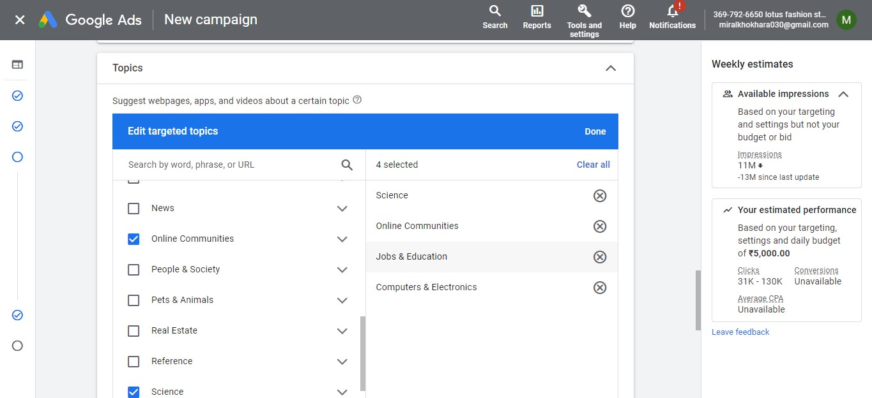

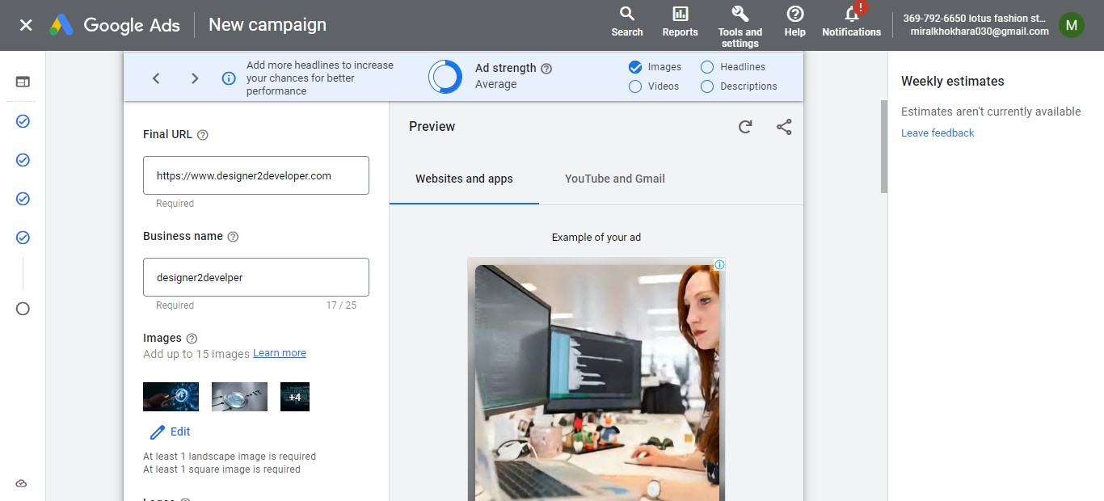

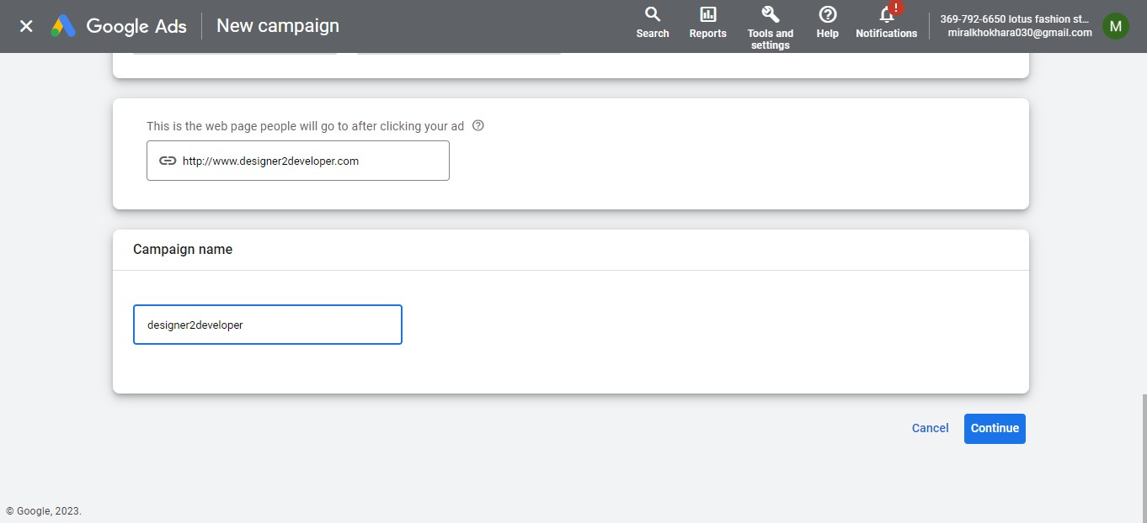

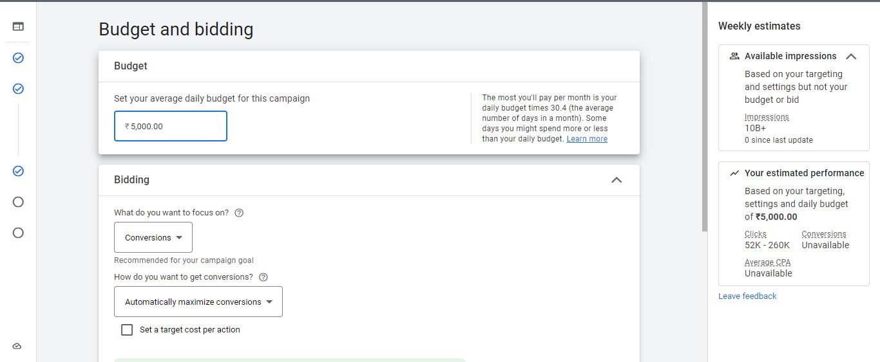

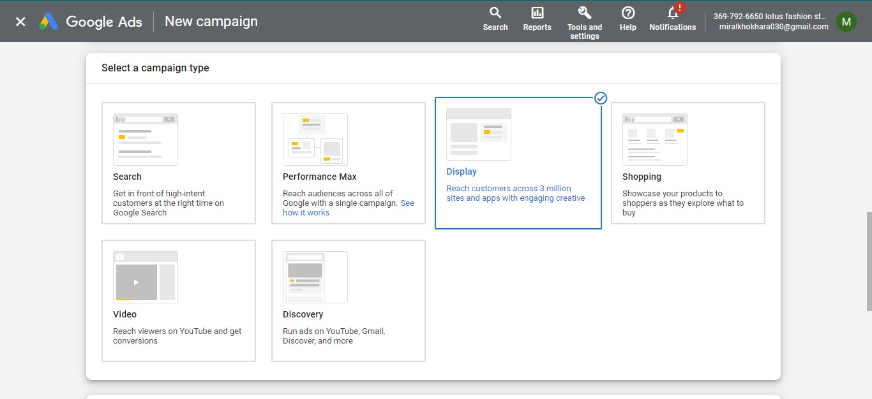

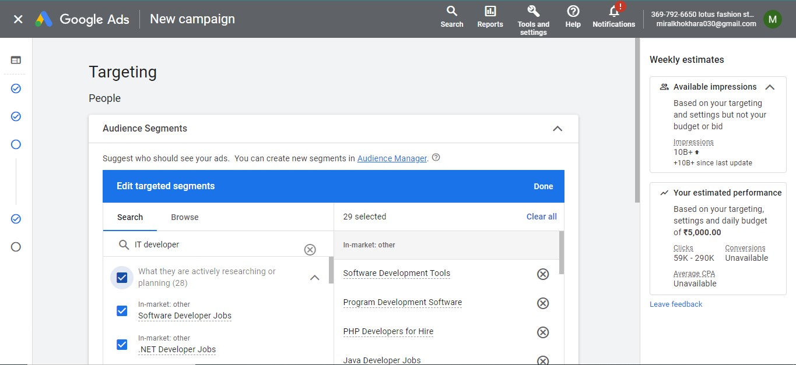

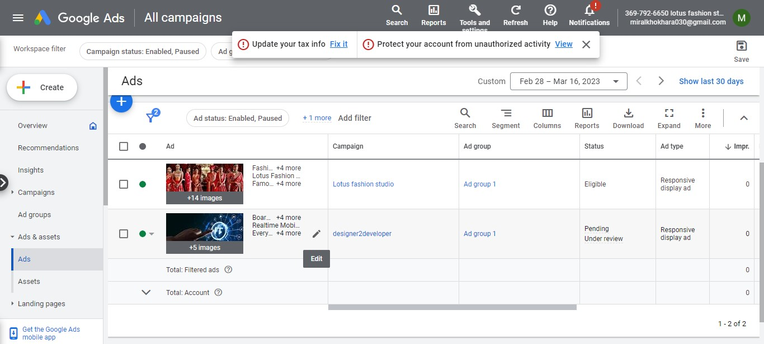

**LINK:-**

<https://ads.google.com/aw_cm/ExternalPreview?hl=en_US&ad=655257377249&adGroup=143330367490&ocid=1193716705&isObfuscatedOcid=false&showMulPreview=true&showVariations=true&creativeType=35&pk=ACMAqCdn0RT9dyU9RIiL1eeAph6zE-RlnX73FStwvG3de_6HJJS0smE2jvFAtbTFhV6GGZRcwFv8e67fm-ZTLaYIexKhh6EQqvlQRqGq5WfScygYu-8kpKqAmf5GLIqqEREIDXwpIgEZloy2nym3-7bVPSCBRolGmK_lGhGDwEa4RvBbecPFVZ86v3Q>